CASE STUDY
CO3 AT2
ITA0502 – COMPUTER VISION
Submitted by

M Yasodha Krishna (192472100)
Under the Supervision of

Dr. R C Jeni Gracia

1. Satellite Image Registration Using Harris Corner Detection

Answer
A remote sensing system must align satellite images of the same geographical region captured at different times. The original edge-based approach becomes unreliable because illumination, image orientation, and background details may vary between images. The proposed solution is to use Harris Corner Detection to identify stable, localized, and distinctive feature points for image registration.
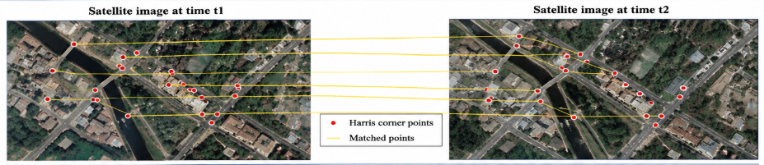
Figure 1. Satellite-image registration using corresponding feature points.

1. Understanding of the Case
The key problem is inaccurate image registration when the same geographical region is observed under different imaging conditions. Edge detection mainly identifies intensity transitions and may produce long, fragmented, or ambiguous edges. Changes in illumination can change the strength and appearance of edges, while background structures may create multiple similar edges. Image orientation can also make direct edge correspondence difficult. Therefore, edge features alone may not provide sufficiently distinctive and localized information for reliable matching.

2. Application of Concepts
Harris Corner Detection is more suitable for identifying localized feature points because it detects locations where image intensity changes significantly in multiple directions. A corner therefore provides a more distinctive reference point than a general edge. The Harris method uses local image gradients and a second-moment matrix to measure the strength of corner-like structures.
The image-registration process can be performed as follows:
- Preprocess the satellite images to reduce noise and, when required, normalize their intensity.
- Compute the horizontal and vertical image gradients.
- Construct the local second-moment matrix from the gradient information.
- Calculate the Harris response and select strong local maxima as corner points.
- Compare local neighborhoods around detected corners to establish corresponding feature points.
- Use reliable correspondences to estimate the geometric transformation between the images.

3. Analysis
Edge detection is sensitive to changes in illumination and often produces features that are not sufficiently distinctive for reliable correspondence. An edge may extend over a large region, making it difficult to determine which point on one image corresponds to a point on the other image. Harris corners are spatially localized and represent intensity variation in multiple directions, providing stronger geometric references for alignment.
As a result, Harris Corner Detection can improve feature localization and matching accuracy when image content changes moderately. It is particularly useful for identifying structural points such as intersections, building corners, and other locally distinctive regions. However, standard Harris detection is not inherently invariant to large rotations or scale changes, so additional preprocessing or feature-matching techniques may be required when such variations are significant.

4. Solution Design
A feasible registration pipeline is:
Acquire the two satellite images → preprocess and normalize → detect Harris corners → compare feature neighborhoods → establish reliable correspondences → reject incorrect matches → estimate the geometric transformation → warp one image to the coordinate system of the other → verify the alignment.
This design directly addresses the weaknesses of the original edge-based approach. Using localized corner correspondences provides more reliable geometric information for estimating the transformation required for image registration.

5. Conclusion
Harris Corner Detection provides localized and distinctive feature points that are generally more suitable than raw edges for matching corresponding regions in satellite images. By using reliable corner correspondences and geometric transformation estimation, the system can achieve improved feature localization, matching accuracy, and registration performance under moderate changes in imaging conditions.

2. Image Representation for Real-Time Object Detection

Answer
An autonomous surveillance system processes high-resolution color images to detect vehicles and pedestrians in real time. Directly processing RGB images increases computational requirements because three color channels must be processed. The case therefore compares RGB, grayscale, and binary representations and evaluates their effect on computational efficiency, edge detection, and feature extraction.
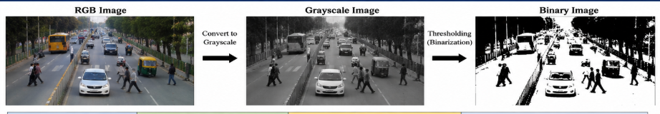
Figure 2. Comparison of RGB, grayscale, and binary image representations.

1. Understanding of the Case
The main requirement is to achieve accurate object detection while maintaining sufficiently low processing time. RGB images contain three color channels and preserve the maximum amount of visual information. Grayscale images represent each pixel using a single intensity value, while binary images represent pixels using two levels.
The choice of representation affects computational efficiency, edge quality, and the amount of information available for feature extraction.

2. Application of Concepts
RGB representation preserves color information and can be useful when color is important for distinguishing objects. However, processing three channels increases computational and memory requirements.
Grayscale representation removes color information while retaining intensity structure. Since many feature-detection and edge-detection algorithms primarily depend on intensity changes, grayscale images provide a good balance between computational efficiency and useful visual information.
Binary representation is computationally simple because each pixel has only two possible values. However, converting an image to binary requires thresholding, which may remove useful texture, shading, and fine object details. Its performance can also be strongly affected by lighting conditions and the selected threshold.
Therefore:
- RGB: Highest information content but higher computational requirement.
- Grayscale: One intensity channel, lower computational cost, and good support for edge and feature detection.
- Binary: Very low computational cost but significant loss of visual information.
For real-time object detection, grayscale is generally the best default representation when color information is not essential to the detection task.

3. Analysis
For edge detection, grayscale is particularly effective because common edge operators use intensity gradients to identify object boundaries. Converting RGB to grayscale reduces the data from three channels to one while retaining the intensity changes required for many feature-detection algorithms.
Binary images can produce clear object boundaries after suitable thresholding, but they may discard weak edges, texture, shading, and internal object features. Therefore, although binary processing can be faster, it may become less reliable in scenes containing shadows, varying illumination, or complex backgrounds.
RGB images preserve additional color information and may provide better performance when color is an important distinguishing feature. However, for a surveillance system focused primarily on shape, edges, corners, and intensity-based features, processing RGB images directly may introduce unnecessary computational cost.
Thus, grayscale provides the most practical compromise between computational efficiency and preservation of useful image information.

4. Solution Design
The recommended real-time processing pipeline is:
Capture RGB image → convert to grayscale → optionally denoise or normalize → perform edge/corner or other feature detection → extract features → detect and classify vehicles and pedestrians.
Binary conversion can be introduced selectively when a reliable segmentation or thresholding stage is available. If color information is essential for distinguishing particular objects, the system can retain selected color information instead of converting the entire image to grayscale.
This approach reduces computational complexity while preserving the intensity information required for reliable feature extraction and object detection.

5. Conclusion
Grayscale is the most appropriate default image representation for accurate and reliable real-time object detection when color information is not essential. It significantly reduces computational and memory requirements compared with RGB while preserving important intensity information for edge and feature detection. Binary representation can provide further computational savings, but its loss of visual information and sensitivity to thresholding make it less reliable as a general-purpose representation. Therefore, grayscale provides the best overall balance between processing speed and detection reliability for the given surveillance application.

